StudySync: MMDC Student Groupmate Matching System - Class Diagram
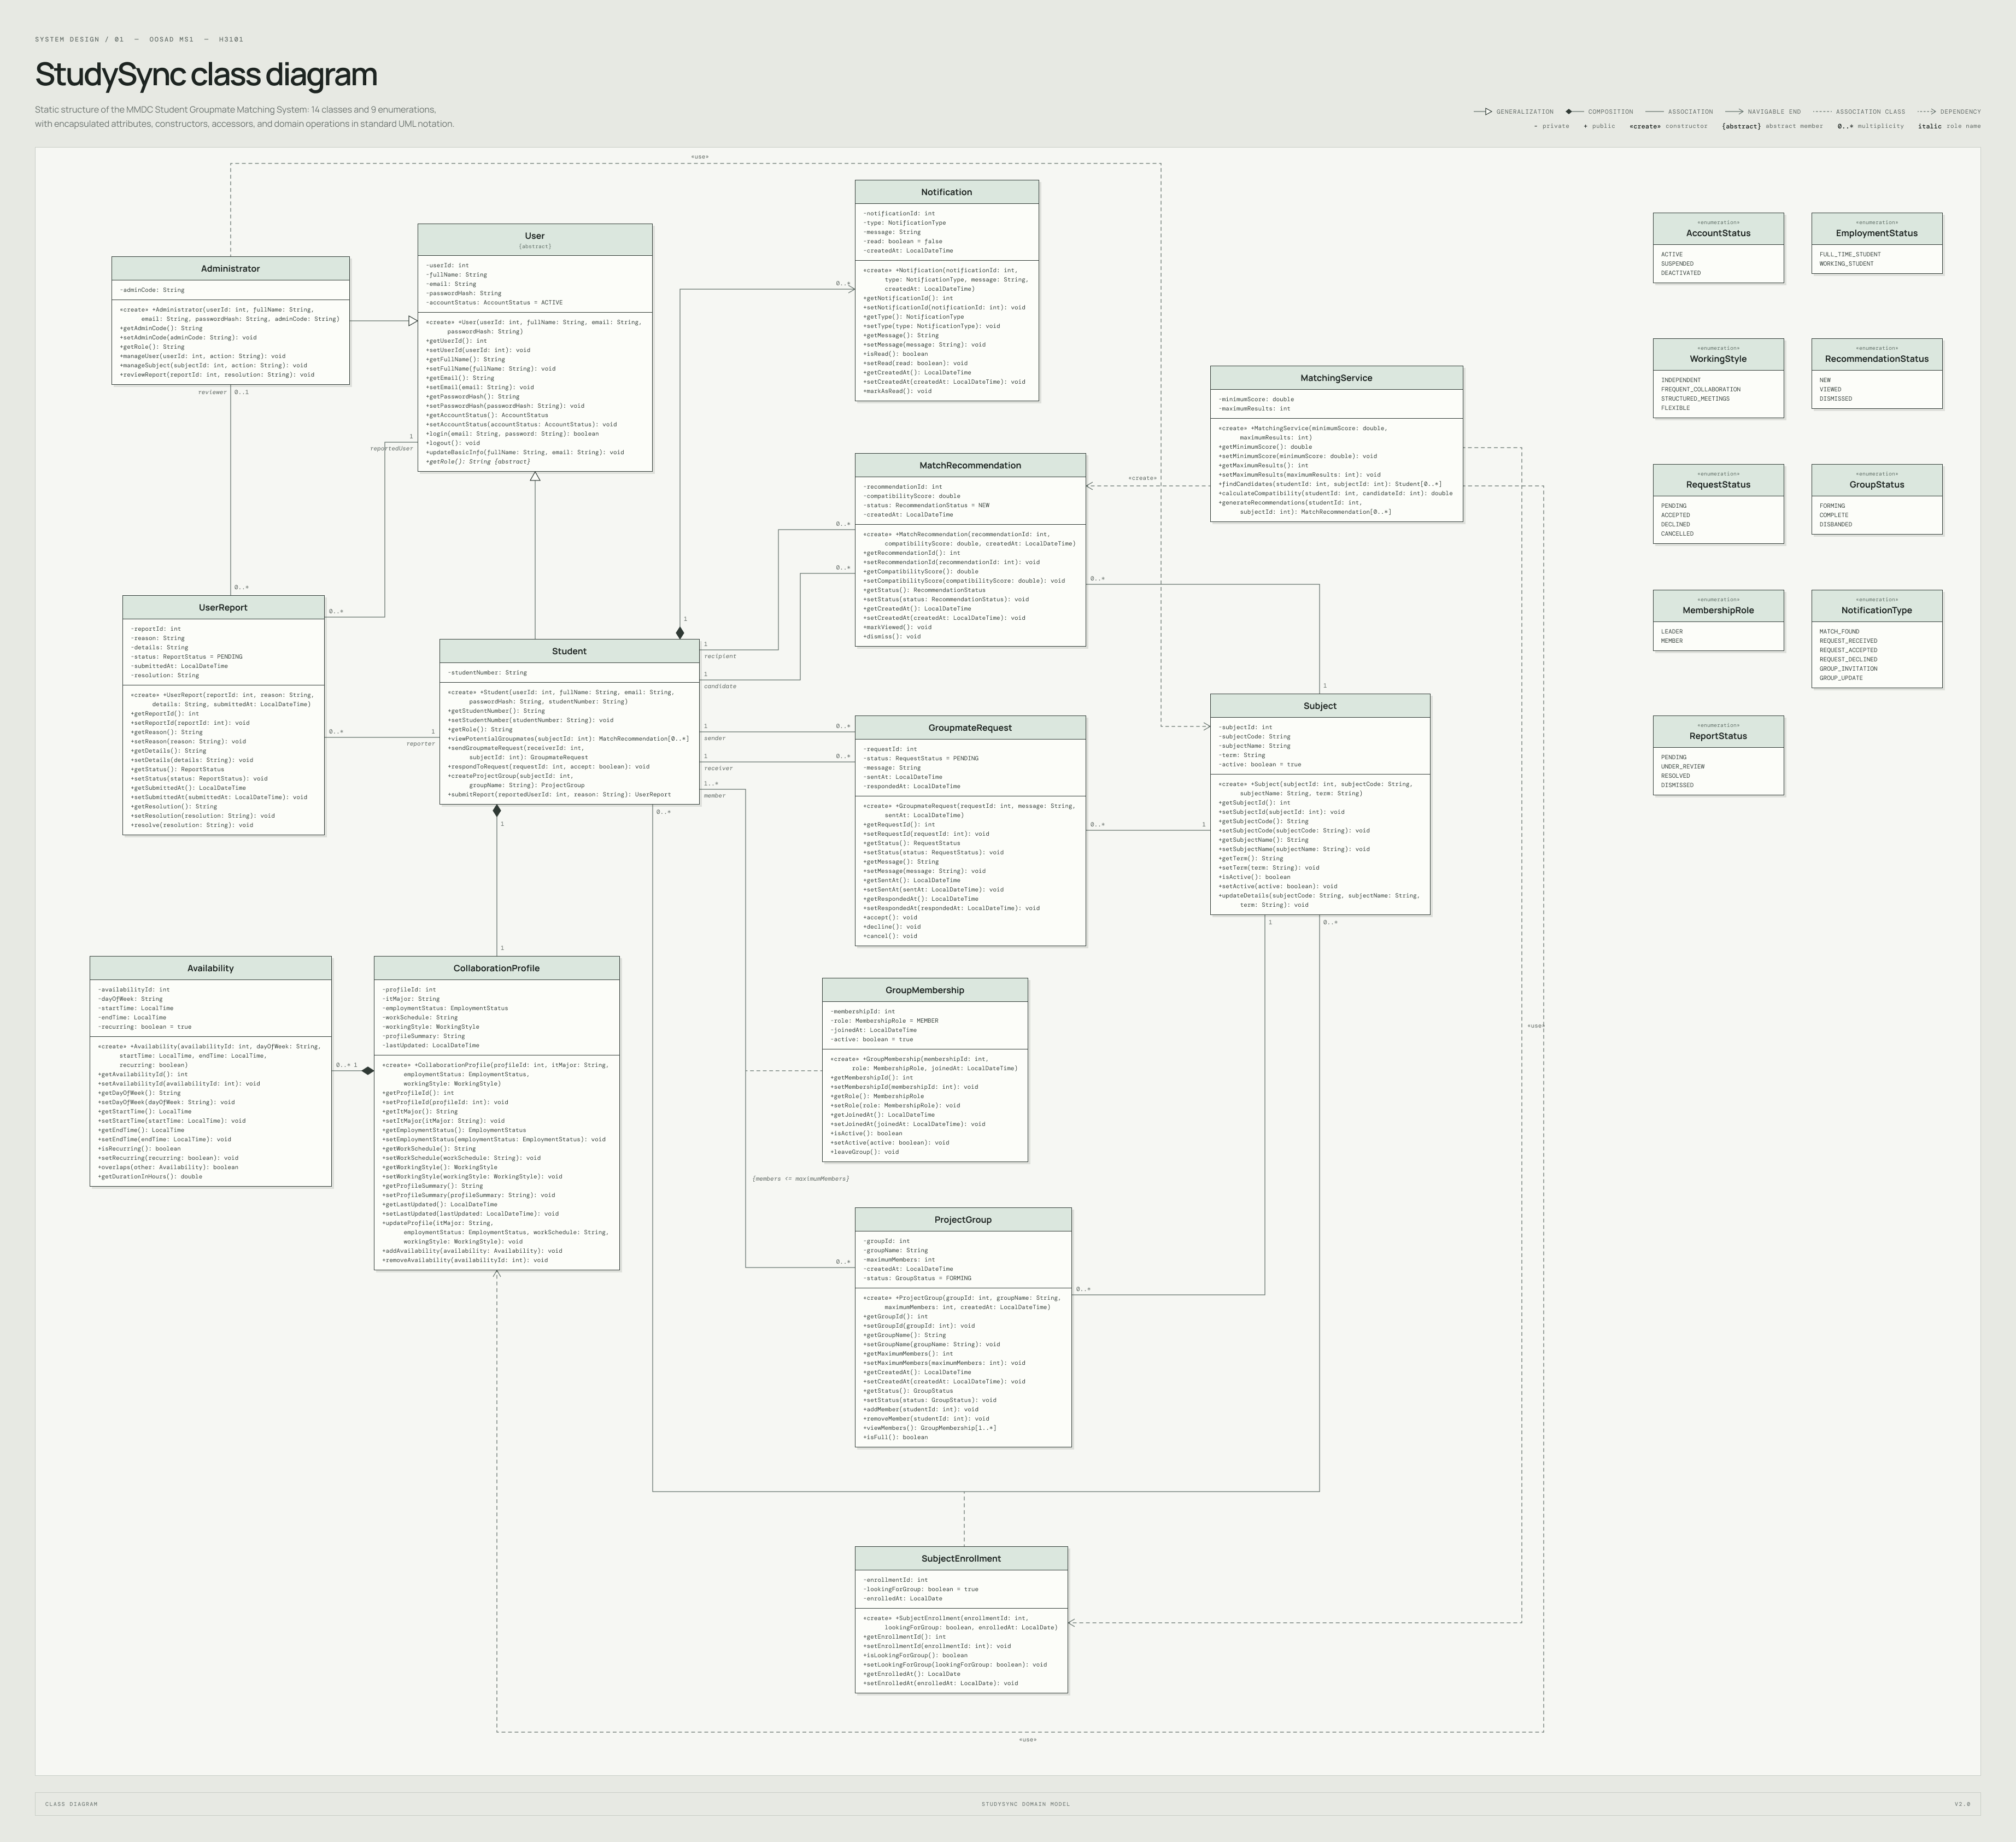
Editable source: StudySync_Class_Diagram.puml. Native editable version: StudySync UML Diagrams (Figma).

